E-Commerce Sales Analysis

Data Analysis Project:
Written Report

By Zubair Gester

Table of Contents
Introduction 2
Tools Used 2
Dataset overview 2
Data cleaning & preparation 2
Exploratory Data Analysis 3
Data Visualization 3
Key insights 5
Business recommendations 6
Conclusion 6

Introduction
Data plays a crucial role in understanding customer behaviour, optimizing product offerings, and improving overall business performance. Companies collect large volumes of transactional data, but meaningful insights can only be extracted through systematic analysis.
This project analyses transactional data from an online retail store to uncover patterns in sales performance, customer purchasing behaviour, and geographic distribution of revenue. The goal of this analysis is to identify key drivers of revenue and provide insights that could help improve business decision-making.
The analysis focuses on answering several key business questions, including identifying the most profitable products, understanding which countries generate the most revenue, and determining which customers contribute most significantly to sales.

Tools Used
- Python – Data cleaning, exploratory analysis and visualizations (Pandas, Matplotlib).
- Tableau - Dashboard Creation.

Dataset overview
The dataset used in this project is the “Online Retail Dataset” available on Kaggle. It contains 500k + records of transactional data from an online retailer between 2010 and 2011, with each row representing a single item purchased in transaction.
Columns: InvoiceNo, StockCode, Description, Quantity, InvoiceDate, UnitPrice, CustomerID, Country.

Data cleaning & preparation
I used Python to clean and preprocess the dataset before performing analysis.
The following steps were performed:
- Removed all duplicate rows.
- Removed all cancelled transactions that were no longer needed (InvoiceNo that starts with “C”).
- Removed rows with missing CustomerID.
- Converted the InvoiceDate column into a datetime format.
- Created a new column called TotalPrice (UnitPrice * Quantity).

Exploratory Data Analysis
I used Python to better understand the structure and distribution of the data. This involved examining summary statistics, identifying key patterns, and generating initial visualizations.
The analysis revealed several interesting characteristics of the dataset:
- Sales are concentrated among a relatively small number of products.
- Customer spending varies widely across the dataset.
- Revenue appears to be strongly influenced by a few major geographic markets.
These observations motivated further analysis of product performance, geographic sales distribution, and customer spending patterns.

Data Visualization
To communicate insights effectively, an interactive dashboard was created using Tableau. The dashboard contains three key visualizations designed to highlight important business patterns.
A) Top 10 Products by Revenue (Pie chart)
A pie chart was used to identify the products generating the highest revenue, as well as the unit price for the specific product.
B) Top 10 Countries by Revenue (Treemap)
To show the geographic distribution of sales by country, showing regions that perform the best.
C) Top 15 highest spending countries (Bar graph)
Bar chart showing the most valued customers that generate the most revenue for the business, what country they are from and their most purchased item.

Tableau Dashboard Link: https://public.tableau.com/views/E-CommerceSalesAnalysisDashboard_17733231986170/Dashboard1?:language=en-US&:sid=&:redirect=auth&:display_count=n&:origin=viz_share_link

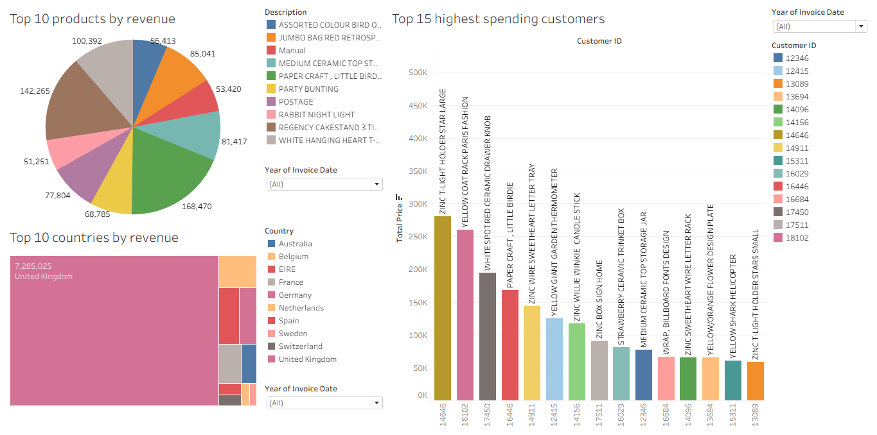
Figure 1: Tableau Interactive Dashboard with top 10 products by revenue, top 10 countries by revenue and top 15 highest spending customers.

Key insights
Top 10 Products by Revenue:
The product that generated the most revenue was Paper Craft, Little Birdie ($168 470), followed by Regency Cakestand Tier 3 ($142 265), White hanging heart T-light holder ($100 392). The rest all generate lower than 100 000 each. Also, most products in the top 10 are very cheap, with 7 of the 10 being less than $10.
The analysis shows that a small number of products contribute a large share of overall revenue. This suggests that the retailer relies heavily on a core group of high-performing items, and also cheap products bring in a lot of revenue.
From a business perspective, maintaining sufficient inventory for these products is critical. These products may also be strong candidates for targeted marketing campaigns or promotional strategies.

Top 10 Countries by Revenue:
The results indicate that revenue is highly concentrated in a small number of countries, with the United Kingdom generating the largest share of sales ($7 285 025). This is expected given that the retailer is based in the UK.
However, several other countries also contribute meaningful revenue, like Netherlands Ireland, Germany and France, mostly European. Australia is the only non- European country in the top 10, suggesting potential opportunities for expanding international market presence.
Understanding geographic demand can help businesses optimize shipping logistics, marketing strategies, and regional promotions.

Top 15 highest-spending customers
The highest value customer is from the Netherlands, with their most purchased item being Zinc T-light Holder Star large, which was not featured in the top 10 products by revenue. Of all the high value customers, only 2 of the most purchased products are among the top 10 by revenue. This shows how even products that aren’t among the best performing individual products, they are still important to keep for high value customers.
All the most purchased products for each high value customer have an average unit price of $6 or lower, once again showing the importance of cheap products.
Targeted retention strategies such as loyalty programs, personalized promotions, or exclusive offers could help maintain strong relationships with these customers and increase lifetime value.

Business recommendations
Inventory management: Ensure reliable stock levels for top-performing products to avoid missed sales opportunities.
Customer retention: Implement loyalty programs or targeted promotions to retain high-value customers.
Market expansion: Explore opportunities to strengthen sales in international markets that already show strong demand, specially outside of Europe.
Product strategy: Focus marketing and promotional efforts on products that consistently generate high revenue, like Paper Craft, Little Birdie, followed by Regency Cakestand Tier 3 and White hanging heart T-light holder.

Conclusion
This project demonstrated how transactional retail data can be transformed into meaningful business insights through data cleaning, analysis, and visualization.
Using Python for data preparation and Tableau for visualization, the analysis revealed important patterns in product performance, customer spending behaviour, and geographic sales distribution.
The findings highlight the importance of focusing on high-performing products, maintaining relationships with valuable customers, and leveraging key markets to drive business growth.

